VIETNAM GENERAL CONFEDERATION OF LABOR

**TON DUC THANG UNIVERSITY**

**FACULTY OF INFORMATION TECHNOLOGY**



**FINAL REPORT**

**DATA MINING**

*Instructor*: **MR. LÊ CUNG TƯỞNG**

*Performers*: **TRẦN NGUYÊN TRƯỜNG – 519H0356**

**VÕ TƯỜNG VI – 519H0098**

*Class***: 19H50302**

*Course*: **23**

**BÙI THỊ HỒNG HẠNH – 51603394**

*Class***:** **16050302**

*Course*: **20**

**THÀNH PHỐ HỒ CHÍ MINH, 2022**

VIETNAM GENERAL CONFEDERATION OF LABOR

**TON DUC THANG UNIVERSITY**

**FACULTY OF INFORMATION TECHNOLOGY**



**FINAL REPORT**

**DATA MINING**

*Instructor*: **MR. LÊ CUNG TƯỞNG**

*Performers*: **TRẦN NGUYÊN TRƯỜNG – 519H0356**

**VÕ TƯỜNG VI – 519H0098**

*Class***: 19H50302**

*Course***: 23**

**BÙI THỊ HỒNG HẠNH – 51603394**

*Class:* **16050302**

*Course:* **20**

**THÀNH PHỐ HỒ CHÍ MINH, 2022**

**THANK YOU**

I would like to thank Mr. Le Cung Tuong, the lecturer of the subject of Data Mining for giving me the knowledge to make this report. Thanks to Ton Duc Thang University library for creating all conditions for us to have research and research materials for our thesis topic. And thanks to all the authors of these resources, We have consulted and extracted them for use in this report.

**PROJECT COMPLETED AT TON DUC THANG UNIVERSITY**

We hereby declare that this is the product of our own project and under the guidance of Mr. Le Cung Tuong. The research contents and results in this topic are honest and have not been published in any form before. The data in the tables for analysis, comments and evaluation are collected by the author himself from different sources, clearly stated in the reference section.

In addition, the project also uses a number of comments, assessments as well as data of other authors, other agencies and organizations, with citations and source annotations.

**If there is any fraud, we will take full responsibility for the content of our project.** Ton Duc Thang University is not related to copyright and copyright violations caused by us during the implementation process (if any).

*Ho Chi Minh city, Friday 15th July 2022.*

*Authors*

*(Sign )*

*Truong*

*Trần Nguyên Trường*

*Vi*

*Võ Tường Vi*

*Hanh*

*Bùi Thị Hồng Hạnh*

**EVALUATION PART OF THE TEACHER WHO MARK THE TEST**

_______________________________________________________________________________________________________________________________________________________________________________________________________________________________________________________________________________________________________________________________________________________________________________________________________________

Ho Chi Minh city, date

(Sign)

**TABLE OF CONTENT**

THANK YOU i

PROJECT COMPLETED AT TON DUC THANG UNIVERSITY ii

EVALUATION PART OF THE TEACHER WHO MARK THE TEST iii

TABLE OF CONTENT 1

LIST OF TABLES, FIGURES, GRAPHICS 3

PART 1: INTRODUCTION 4

1.1 Background 4

1.2 Purpose and scope 4

1.3 Overview about the report 4

PART 2: METHODOLOGY 5

2.1 Crawl data 5

2.1.1 Crawl Shopee Mall 5

2.1.2 Crawl comments from Shopee Mall product 7

2.2 Feature implementation 10

2.2.1 Monthly revenue of stores 11

2.2.2 Sentiment analysis 11

2.2.3 Determine the average number of stars 11

2.2.4 Other features 11

2.3 Cluster data 12

2.3.1 Using elbow method 12

2.3.2 Using k-mean 12

PART 3: SELF EVALUATION 16

3.1 Conclusion 16

3.2 Self evaluation 16

REFERENCES 17

**LIST OF TABLES, FIGURES, GRAPHICS**

Figure 1. Headers and API for Crawl data 6

Figure 2.Function to get all categories from Shopee 6

Figure 3. Function crawl all brand information from Shopee Mall 7

Figure 4. Save data of Shopee Mall to file ShopeeMall.csv 7

Figure 5. Function to crawl products information 9

Figure 6. Save products of shop to file csv 9

Figure 7. Get comments of every shop's products 10

Figure 8. Save comments of shop to file csv 10

Figure 9. Number of sold product and price 11

Figure 10. Sentiment analysis using underthesea 12

Figure 11. Average stars stored in dataset 13

Figure 12. The Elbow method using Distortion 14

Figure 13. Input 14

Figure 14. Flattened Graph 15

**PART 1: INTRODUCTION**

**1.1 Background**

Nowadays, data surrender mining solutions enable organizations to learn from all customer interactions, gain operations and information context faster, and generate insights that can work efficiently. and execute detailed information to find, optimize, and engage targets.

**1.2 Purpose and scope**

This is the project to apply our knowledge about data mining. The project is about simple crawl data technique and technique about pre-processing data and applying methods to determine the number of clusters for the data.

**1.3 Overview about the report**

In this report, we will work to crawl data from Shopee – an e-commercial platform in Viet Nam and use that data for a lot of work:

* Estimated sales of stores in Shopee
* Determine the average number of stars that users rate, chat response rate, number of shop followers
* Using the elbow method to determine the number of clusters that best match the collected data, draw an illustrative graph.
* Cluster the above shops using k-means and visualize them on the graph

**PART 2: METHODOLOGY**

**2.1 Crawl data**

Crawl is data scraping (Crawl Data) is a term that is not new in Marketing, and SEO. Crawl is a technique that search engines use such as Google, Bing, Yahoo... The main job of a crawl is to collect data from any page. Then proceed to analyze the HTML source code to read the data. And filter out according to user requirements or data that Search Engine requires.

***2.1.1 Crawl Shopee Mall***

In this section, we use selenium and request – two libraries in python and call API to help collect data the most effective way. The crawling process is carried out according to the following steps :

1. Crawl all categories of shopee mall and save to categories_link.txt. This step does not need to switch pages much, so it is crawled with the HTML DOM based on selenium.
2. Use category links to crawl shops in a category. Get 5 shops in each category. This step still crawls with selenium and we have got there following features:

* link shop (a.full-brand-list-item__brand-cover-image)
* name shop (div.full-brand-list-item__brand-name)

To get shop details like {'country', 'shop_location', 'user_id', 'shop_id', 'cancellation_rate', 'response_rate', 'rating_normal', 'rating_bad', 'rating_good', 'total_avg_star', 'follower_count', 'following_count', 'item_count'} we have use API from Shopee:

* <https://shopee.vn/api/v4/shop/get_shop_detail?username=>{}
* [https://shopee.vn/api/v2/shop/get_categories?limit={}&offset={}&shopid={}](https://shopee.vn/api/v2/shop/get_categories?limit=%7b%7d&offset=%7b%7d&shopid=%7b%7d)

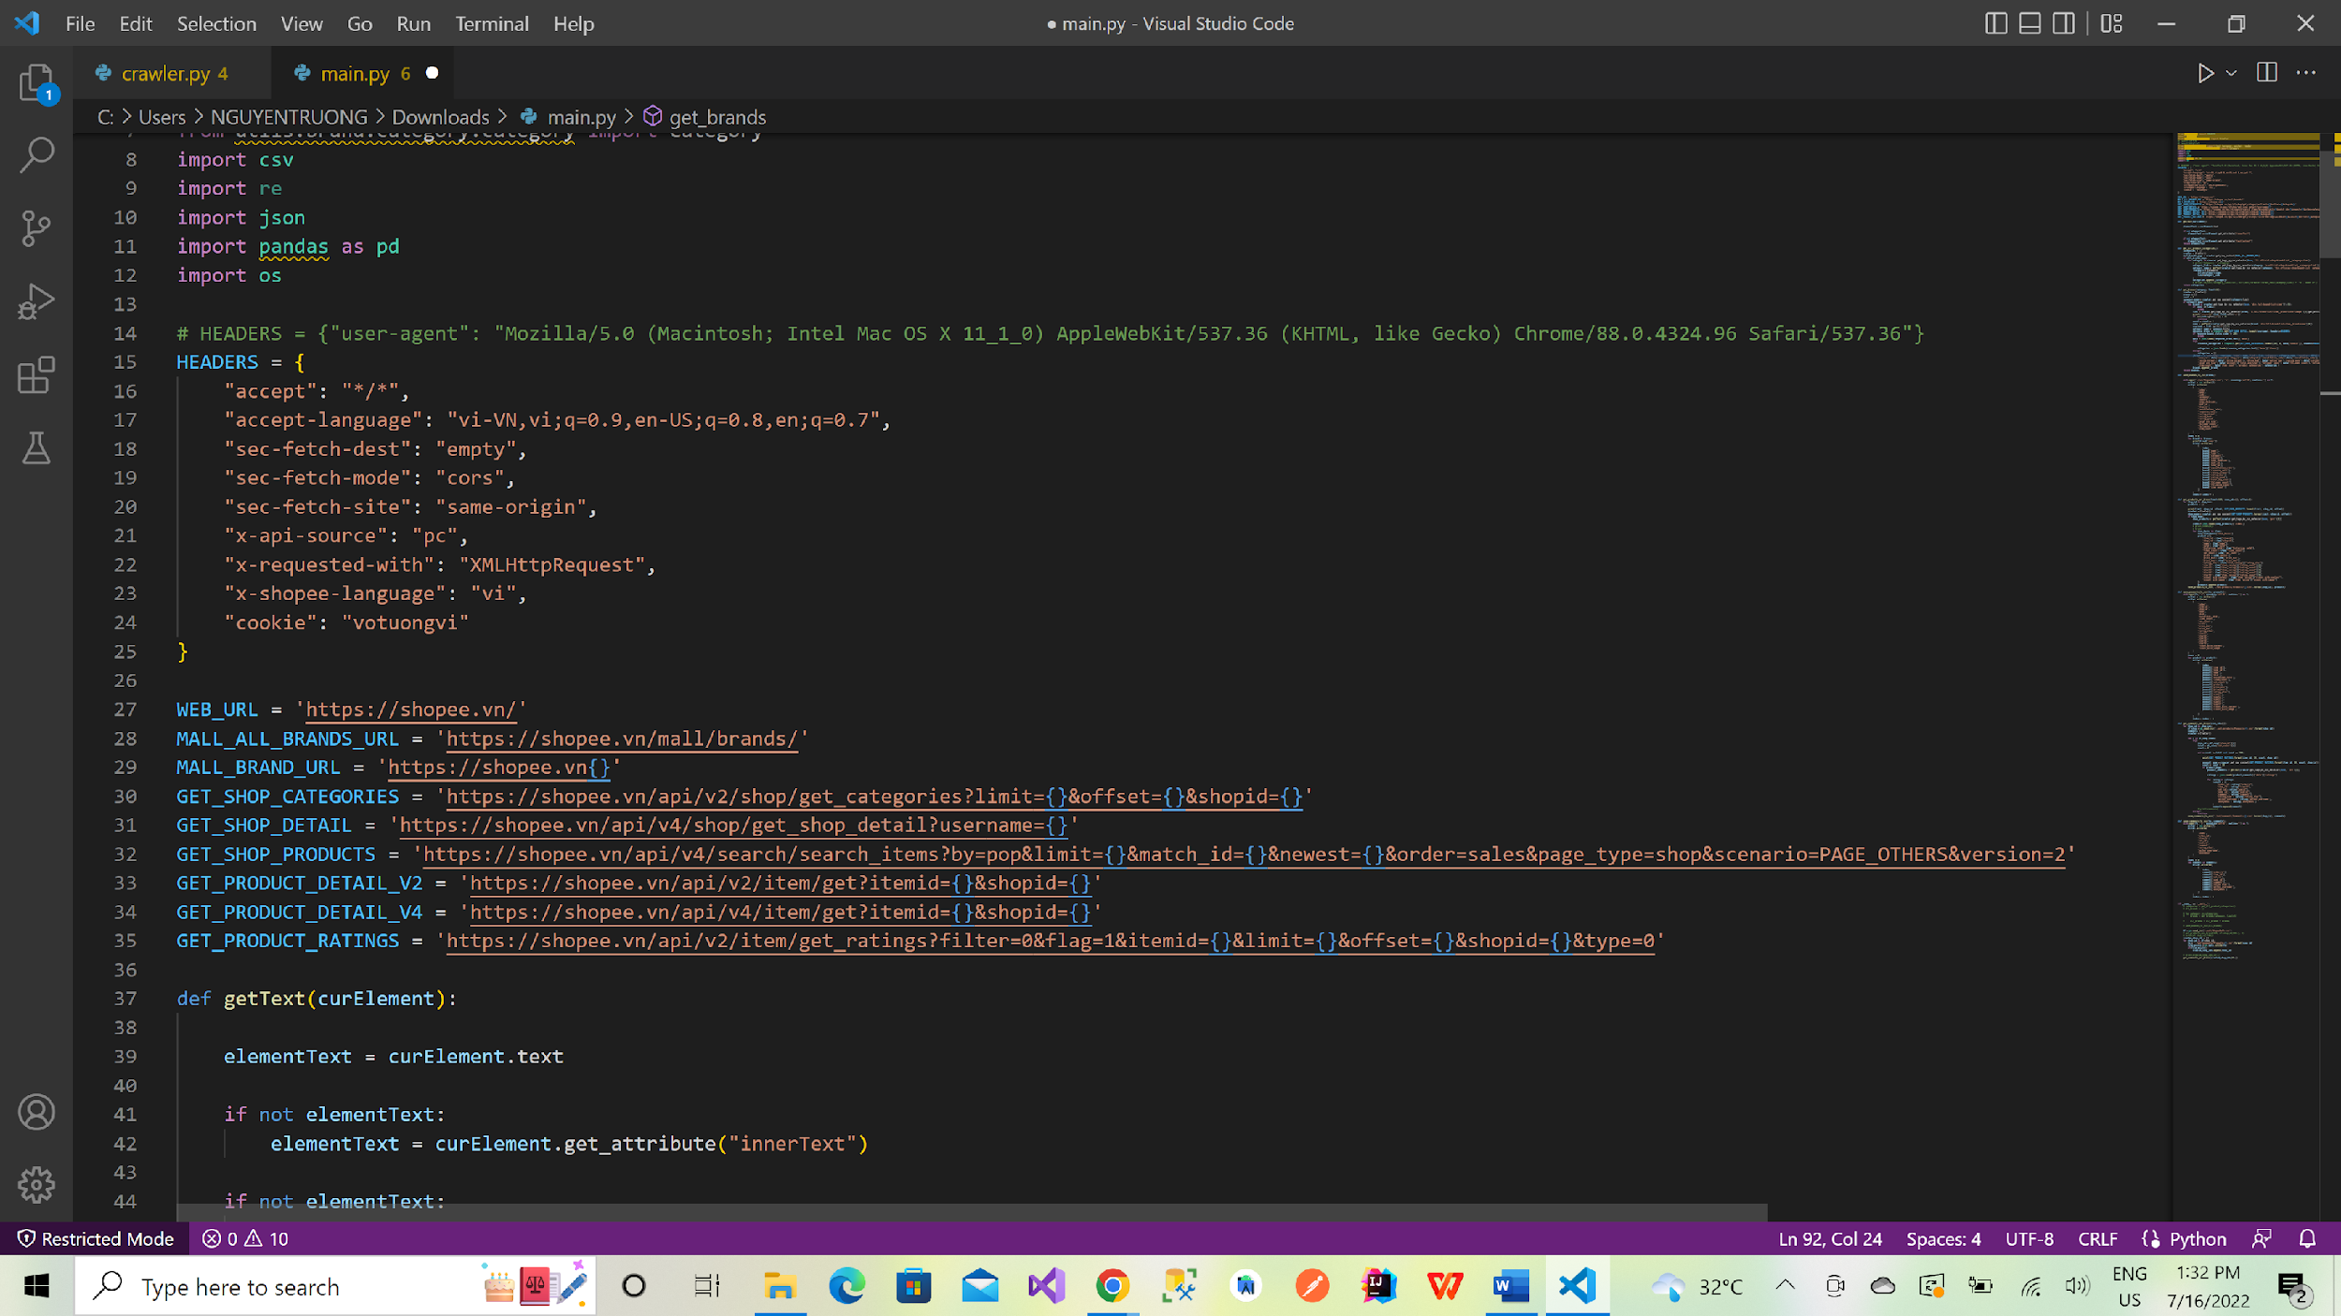

Figure . Headers and API for Crawl data

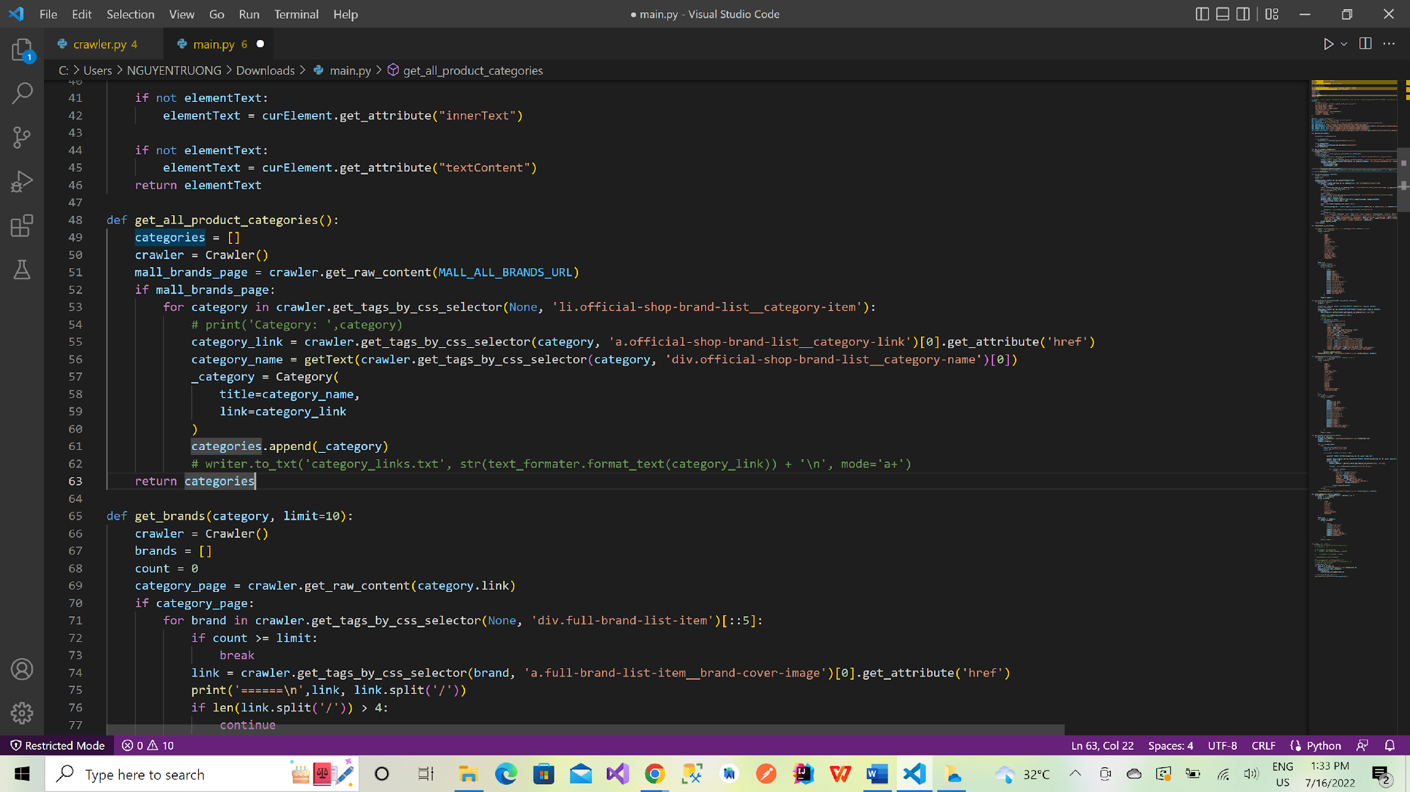

Figure .Function to get all categories from Shopee

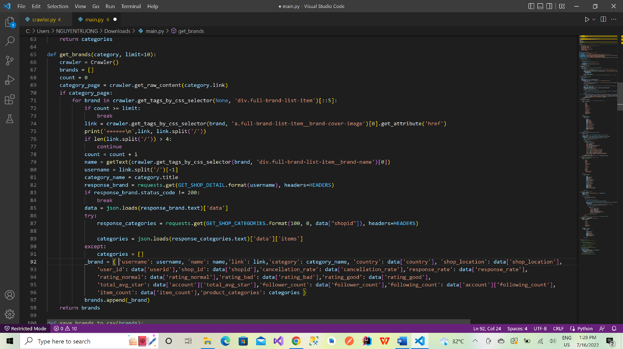

Figure . Function crawl all brand information from Shopee Mall

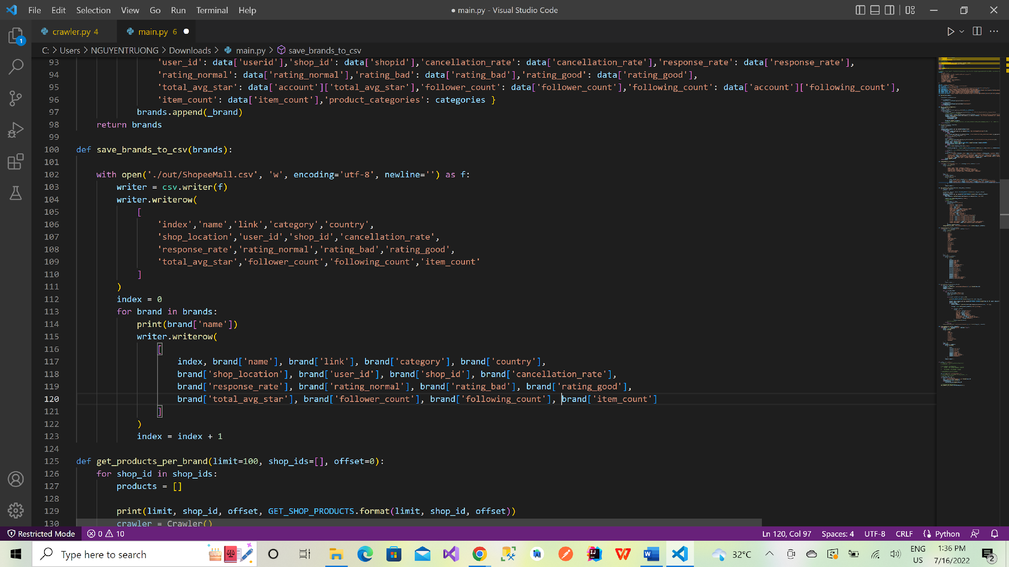

Figure . Save data of Shopee Mall to file ShopeeMall.csv

***2.1.2 Crawl comments from Shopee Mall product***

From step two in section 2.1.1, we will have {shop_id} – id of Shopee Mall. From that we can use it to get all products of a Shopee Mall. The API for this step is ‘[https://shopee.vn/api/v4/search/search_items?by=pop&limit={}&match_id={}&newest={}&order=sales&page_type=shop&scenario=PAGE_OTHERS&version=2](https://shopee.vn/api/v4/search/search_items?by=pop&limit=%7b%7d&match_id=%7b%7d&newest=%7b%7d&order=sales&page_type=shop&scenario=PAGE_OTHERS&version=2)’ .However, because Shopee block access through unauthenticated tool so we have decided to combine API access with selenium through the interface to get DOM tag <pre> to get json response. From that we can get all product features of Shopee Mall are {'item_id', 'shop_id', 'name', 'sold', 'historical_sold', 'liked_count', 'cmt_count', 'price', 'price_min', 'price_max', 'rating_star', 'start1', 'start2', 'start3', 'start4', 'start5', 'rcount_with_context', 'rcount_with_image'}, the feature {sold} is monthly revenue of shop.

After get {item_id, shop_id} we will use combination of selenium and call API ('[https://shopee.vn/api/v2/item/get_ratings?filter=0&flag=1&itemid={}&limit={}&offset={}&shopid={}&type=0](https://shopee.vn/api/v2/item/get_ratings?filter=0&flag=1&itemid=%7B%7D&limit=%7B%7D&offset=%7B%7D&shopid=%7B%7D&type=0&fbclid=IwAR3OshgNhOtHM9iC_5yffKaWd3YvPhxkHwCW7gfS91RVG7Kx4MRO0vkk0jw)') . The result of this process is that we can get comments of Shopee Mall and it features like {'order_id', 'item_id', 'cmt_id', 'user_id', 'comment', 'rating_star', 'author_username', 'anonymous'}.

The data that we crawl in this section will be save into files below:

* ShopeeMall.csv: Save the information of shop we have crawl in section 2.1.1
* category_link.txt: Save the link for categories of Shopee
* Products-{shop_id}.csv: With {shop_id} is a param that is identify key of every shop, those file will have data of shop’s products that we have crawl in section 2.1.2
* Comments-{shop_id}.csv: With {shop_id} is a param that identifies the key of every shop, those files will have the data of shop’s products comments from products that crawled in section 2.1.2 .

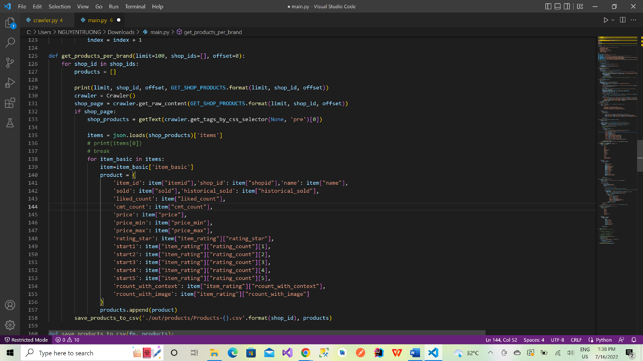

Figure . Function to crawl products information

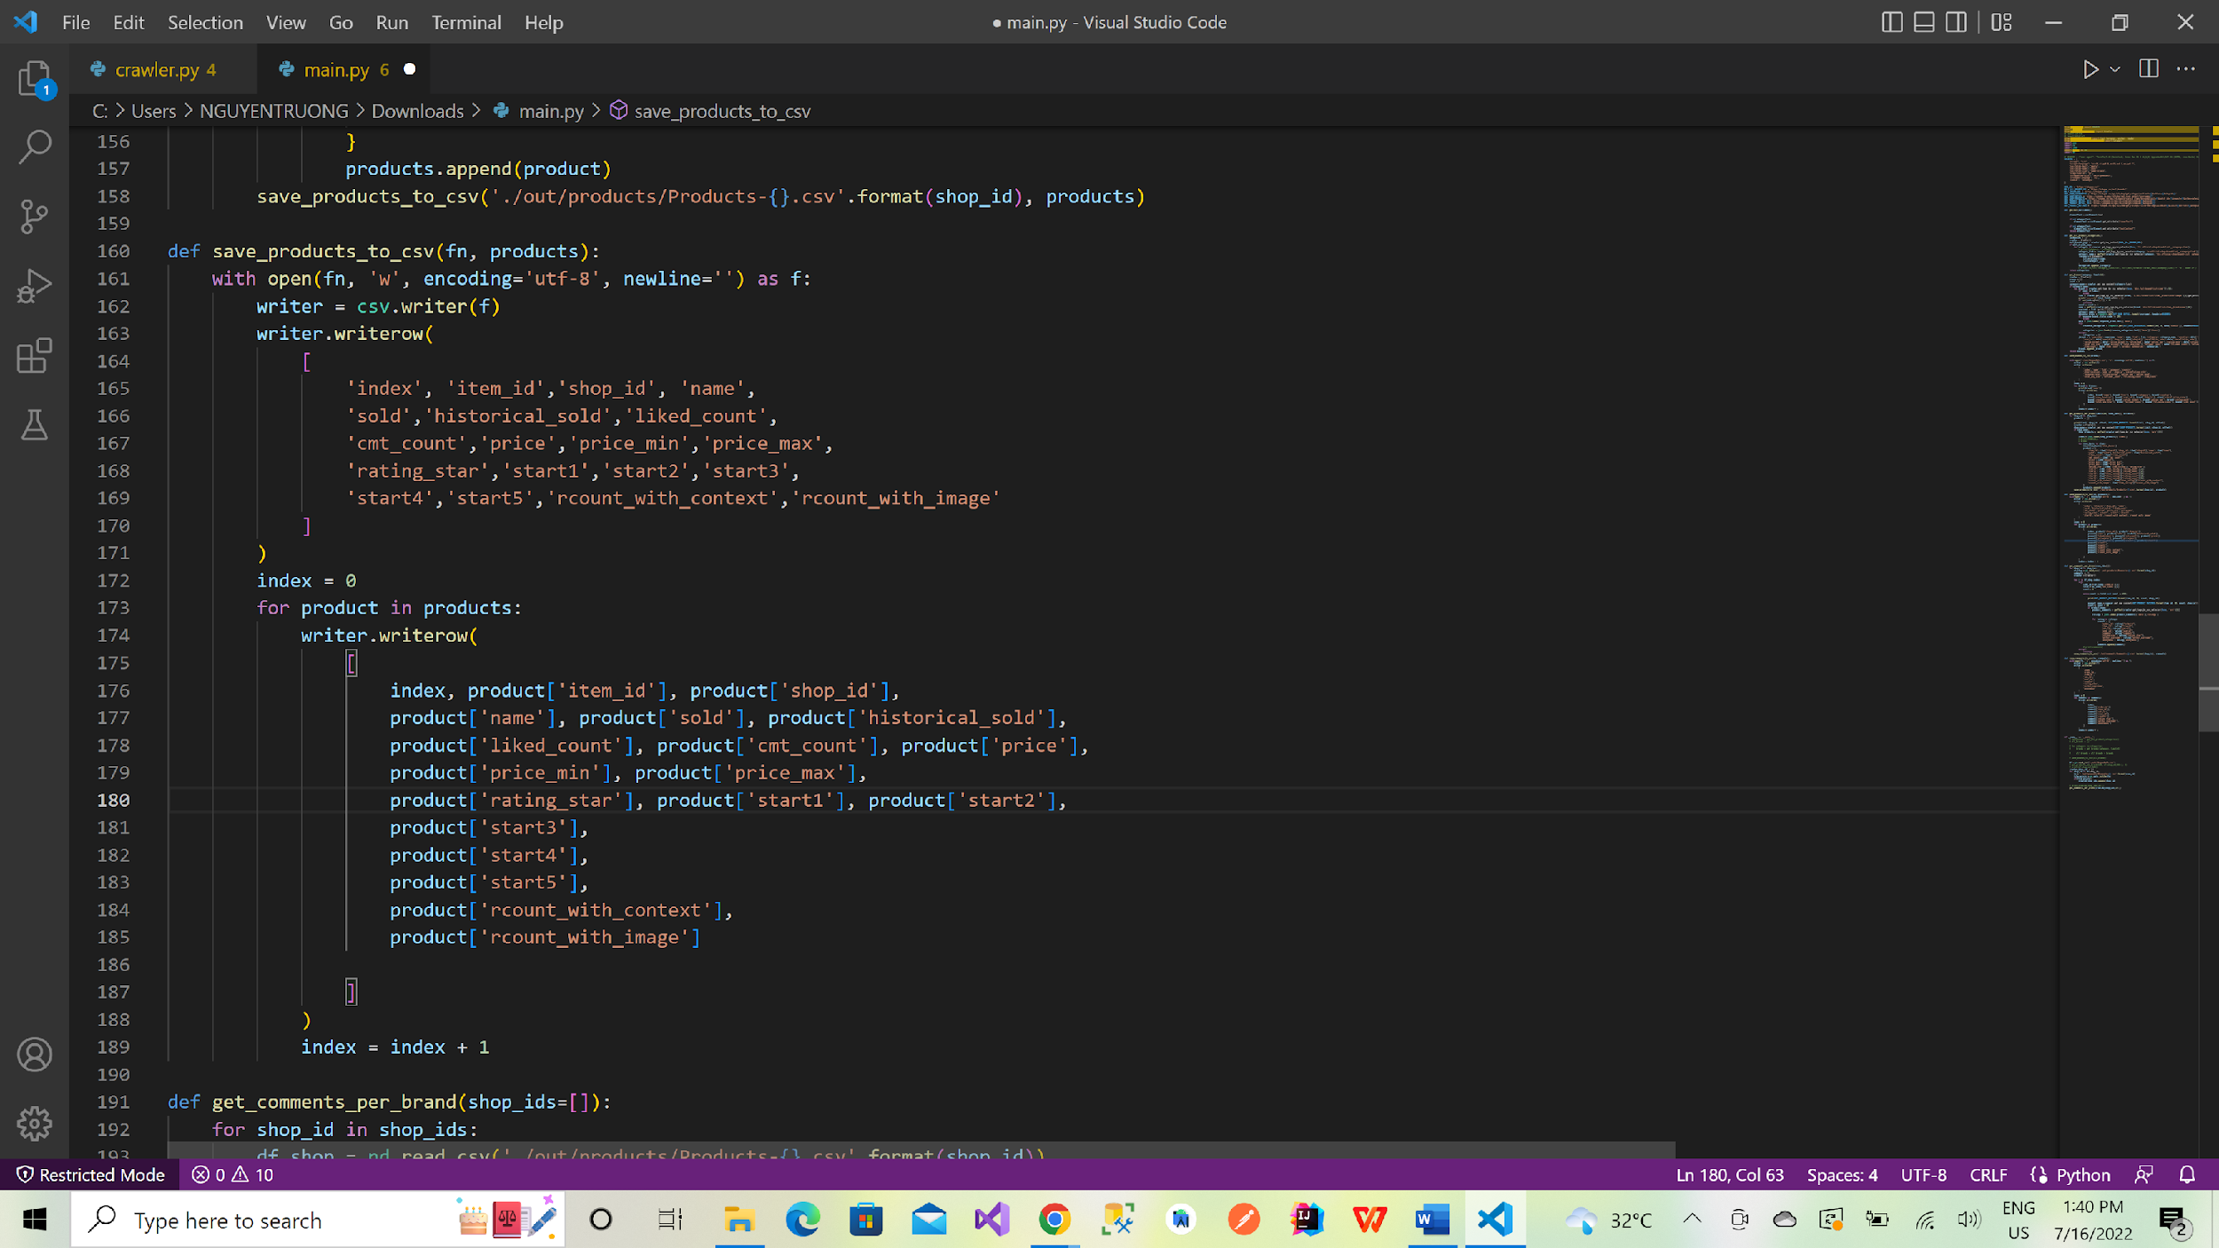

Figure . Save products of shop to file csv

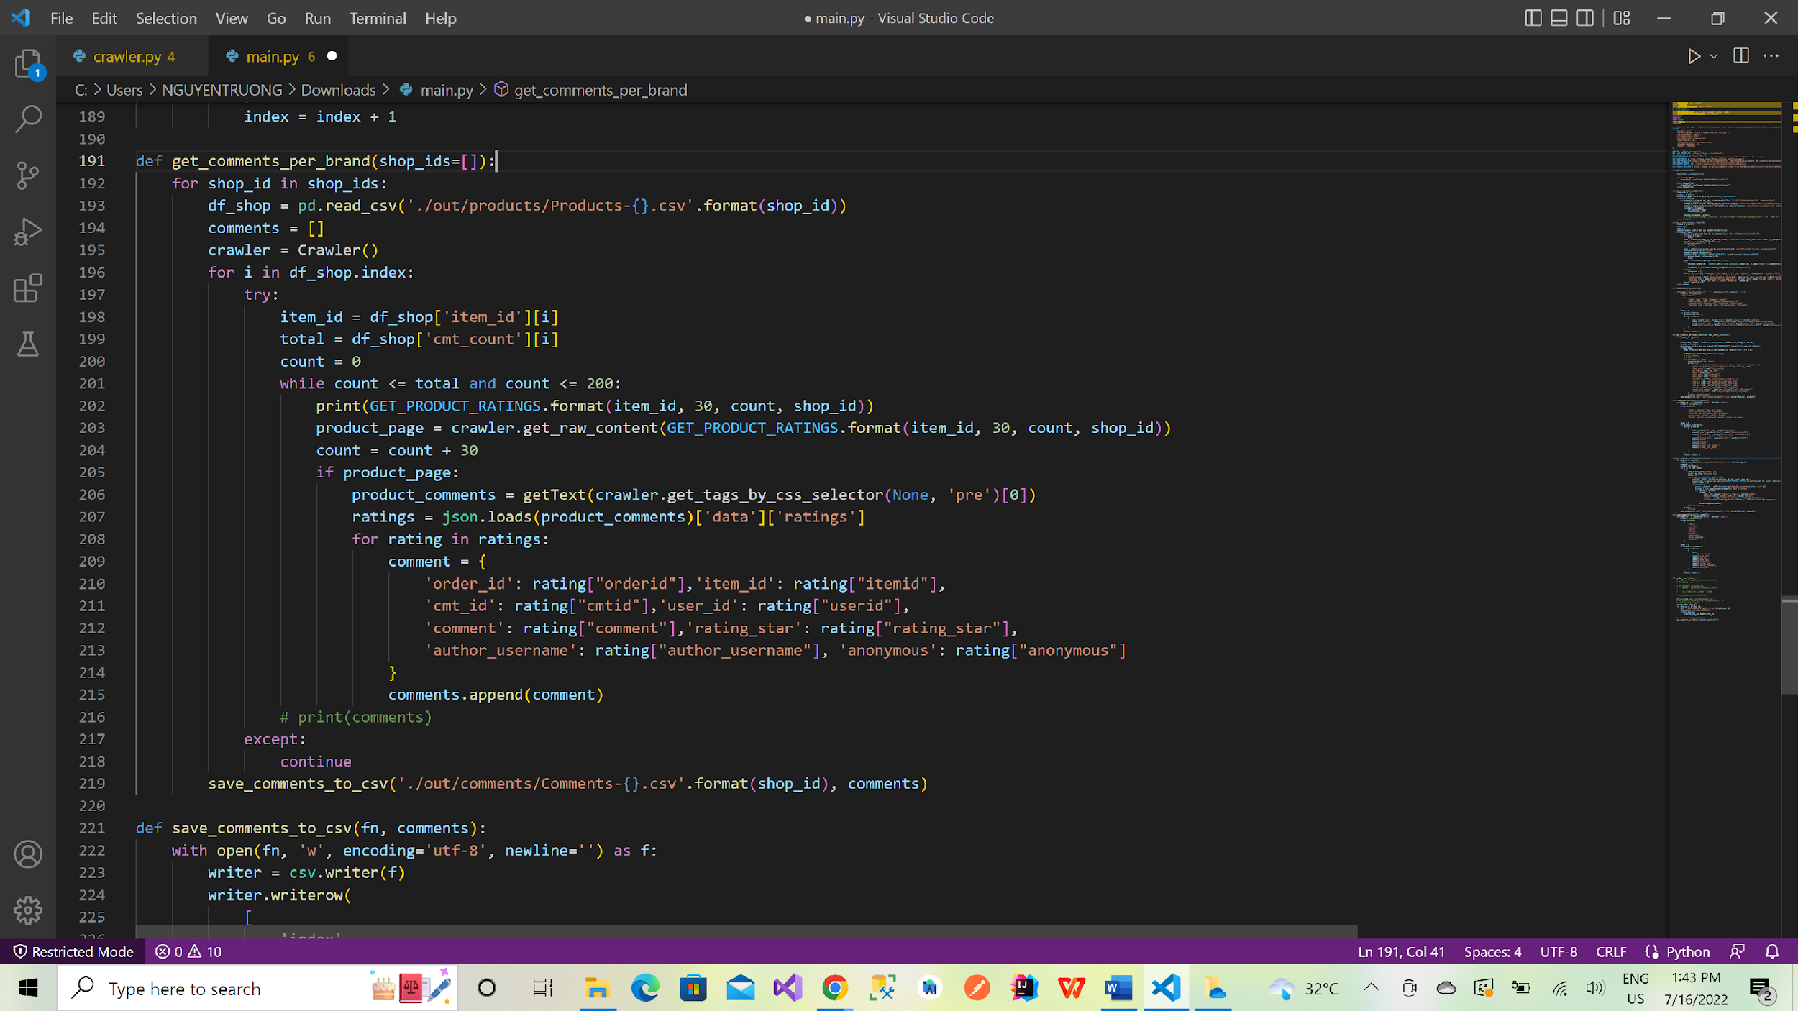

Figure . Get comments of every shop's products

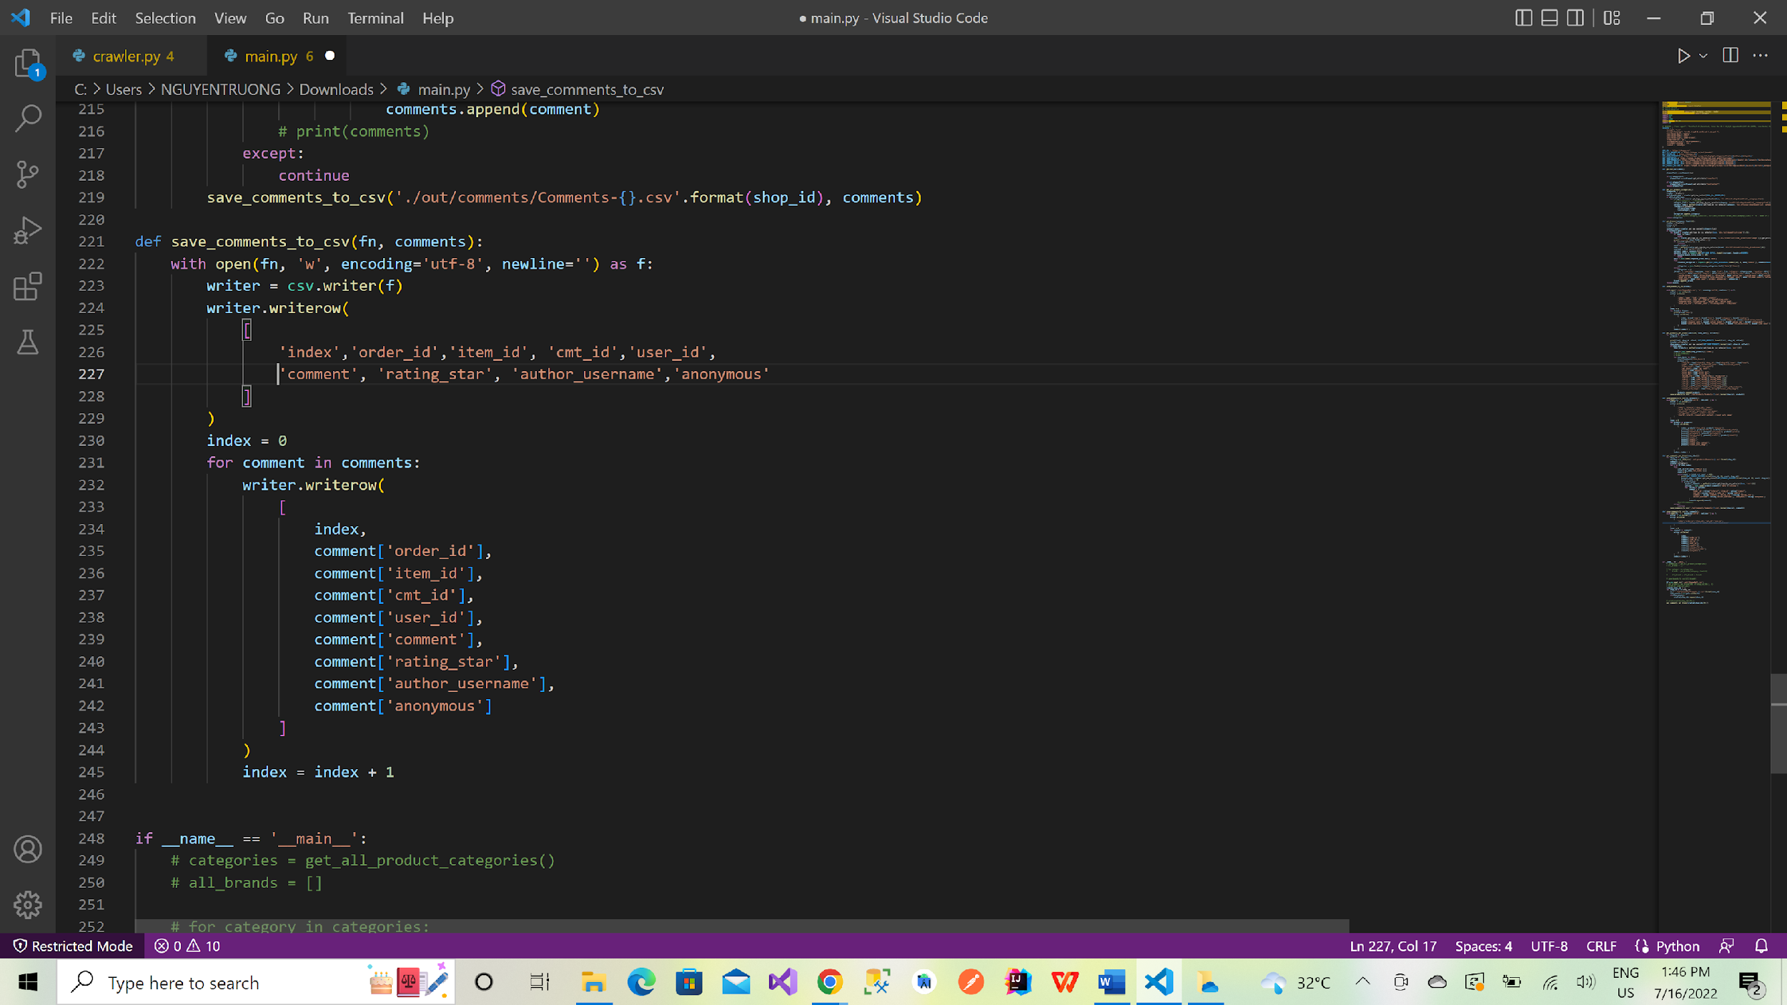

Figure . Save comments of shop to file csv

**2.2 Feature implementation**

From the data we crawl in section 2.1, we will use that data to do those section below

***2.2.1 Monthly revenue of stores***

Revenue is the total amount of money earned in the process of buying and selling goods, providing services, and other activities of an individual or organization. sales report. Is the profit after completing the payment of taxes, maintenance, depreciation, ... In this section, we will calculate the monthly revenue of every Shopee Mall that we crawl in section 2.1.1.

We also have the number of products that sold in month so we can calculate it with the formula: revenue = price * sold

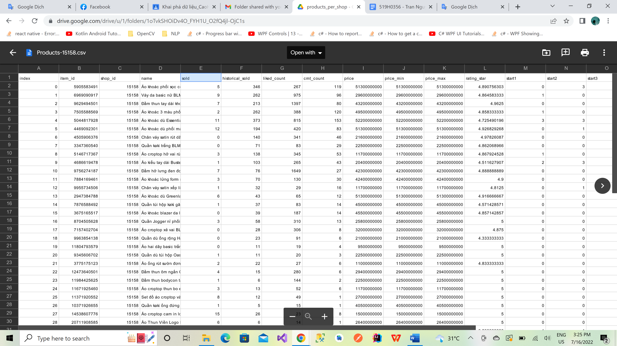

Figure . Number of sold product and price

***2.2.2 Sentiment analysis***

Sentiment analysis (or opinion mining) is a natural language processing (NLP) technique used to determine whether data is positive, negative or neutral. In this section, we will do sentiment analysis with comments that we have crawled in section 2.1.1. This work will use underthesea - a toolkit to support the research and development of Vietnamese natural language processing. Underthesea was born in March 2017, in the context of Vietnam, there are some pretty good toolkits such as vn.vitk, pyvi, but still lack a complete toolkit, open source, easy to install and use like other tools. equivalent products for English like nltk, polyglot, spacy.

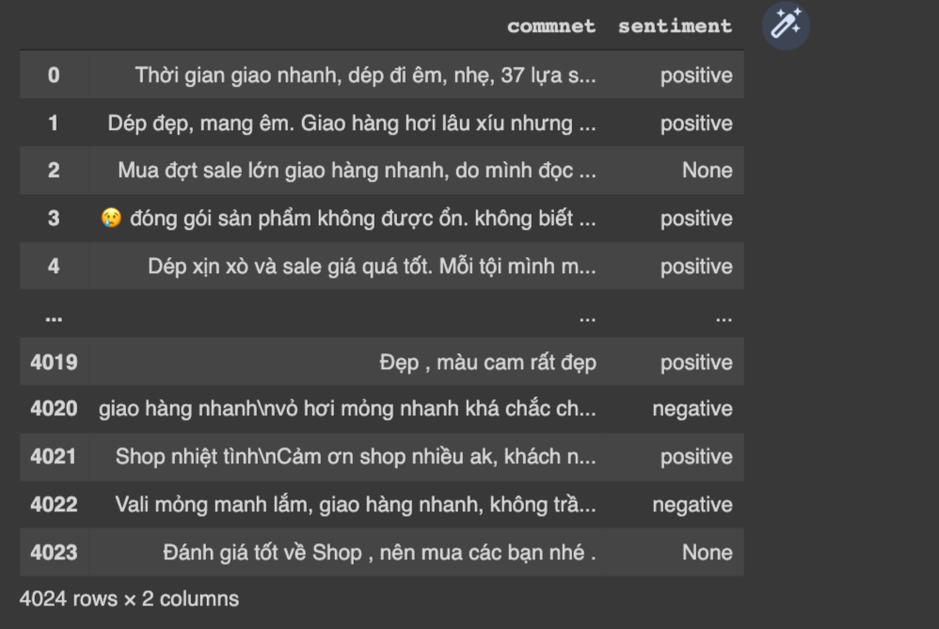

Figure . Sentiment analysis using underthesea

***2.2.3 Determine the average number of stars***

Because of we are using crawl data with selenium combine with API so the average number of stars of each shop is available in data crawled so we don’t have to calculate it.

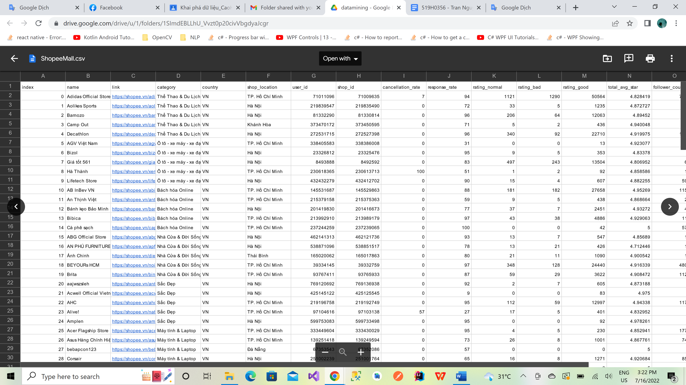

Figure . Average stars stored in dataset

***2.2.4 Other features***

Some features that we think meaningful:

* Shopee Mall other features: Shop location, country, follower count, item count
* Product other features: Historical sold, liked count, comment count, price min, price max, rcount with context, rcount with image
* Comment other features: Author username, anonymous

Way to collect above features: Using API from Shopee

**2.3 Cluster data**

***2.3.1 Using elbow method***

Elbow method is a commonly used method to select a reasonable number of split clusters based on the histogram, however there are some cases where we will not easily detect the position of the Elbow, especially for data sets where the clustering rule is not really easy to detect.

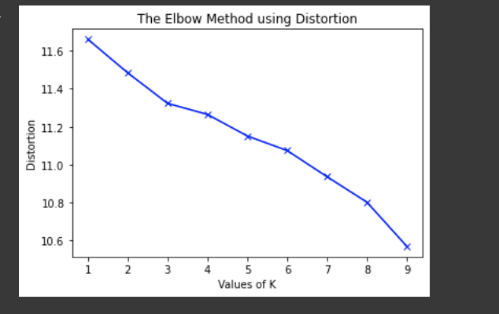

Figure . The Elbow method using Distortion

***2.3.2 Using k-mean***

* Input:

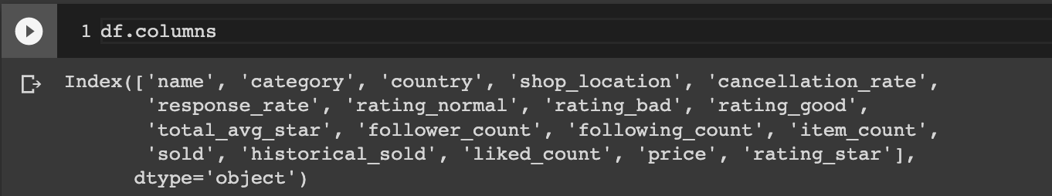

Figure . Input

* ***Preprocessing Data :***
  + Cleaning: described in the cleaning data step
  + Data Transform: convert “Object" type to “Category" type in feature “Country"
* ***Data Transform:***
  + One-hot coding
  + Prepare Data for training (split dataset training/testing)

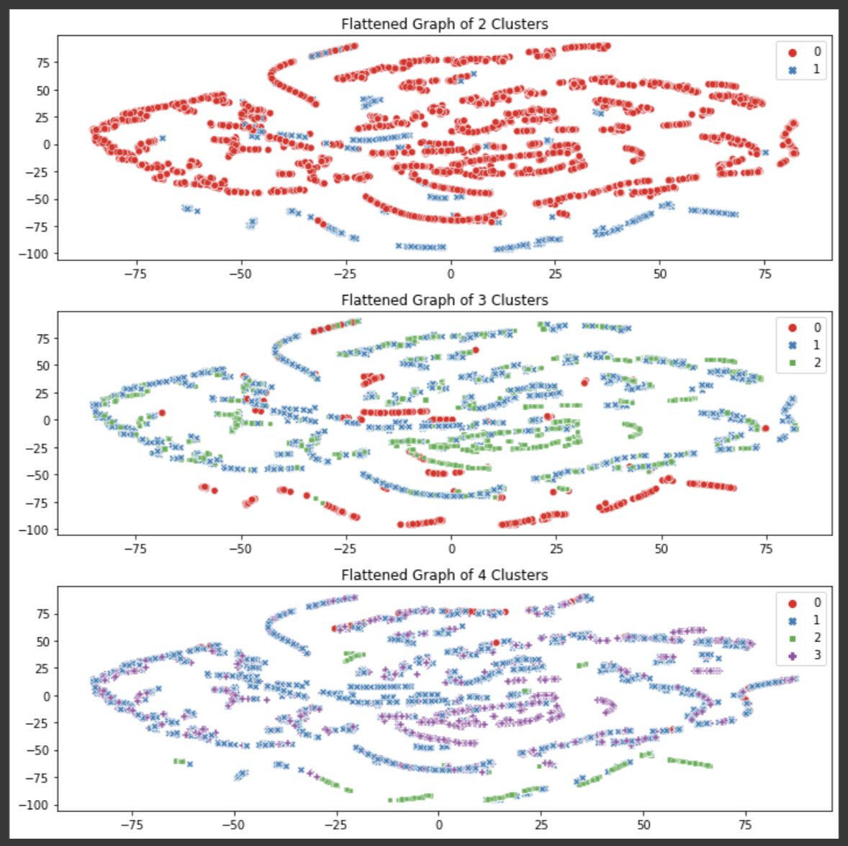

Figure . Flattened Graph

**PART 3: SELF EVALUATION**

**3.1 Conclusion**

We have tried our best to make the crawl data process as fast as possible (we have found out the API of Shopee and combine crawl between call API and using selenium for UI crawl ) .

Because we have used the API of Shopee so we have determined the monthly revenue of Shopee Mall as accurately as possible.

**3.2 Self evaluation**

|  |  |
| --- | --- |
| Task number | self-assessment score |
| Task 1: Crawl 100 Shopee Mall and save to ShopeeMall.csv | 1.0 |
| Task 2: Calculate the monthly revenue of Shopee Mall | 2.0 |
| Task 3: Collect all product reviews of each shop (For each product, get the top 200 comments). Then use the underthesea library to do sentiment analysis | 1.5 |
| Task 4: Define feature | 1.0 |
| Task 5: Determine the average number of stars that users rate, chat response rate, number of shop followers | 1.0 |
| Task 6: Think of other features (must make sense) and how to collect the above features. | 2.0 |
| Task 7: Using the elbow method to determine the number of clusters that best match the collected data, draw an illustrative graph. | 1.0 |
| Task 8: Cluster the shops above using k-means with k found in Task 7. Visualize them on the graph | 2.0 |
| Total | 9.5 |

**REFERENCES**

1. <https://www.selenium.dev/>
2. <https://shopee.vn/>